Code structure for agile concepts

* + 1. Gatekeeper prototype
    2. Auto regression testing prototype
    3. Issue Analysis & Notification prototype

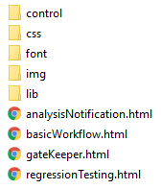

./basicWorkflow.html

* Is the start page, which contains a workflow diagram for all those agile concepts. Click the elements in the workflow will redirect to related concept interfaces.

./gateKeeper.html

* Demonstrates the concept for gate kepper

./regressionTesting.html

* Demonstrates the concept for auto regression testing

./analysisNotification.html

* Demonstrates the concept for issue analysis & notification

./control

* Contains three files (basicWorkflowControl.js, gateKeeperControl.js, regressionTestingControl.js) to control the logic of the corresponding prototype interfaces

./css ./lib ./img ./font

* Are the stylesheets, UI libraries, image source, font resource of those prototype
  + 1. Code review

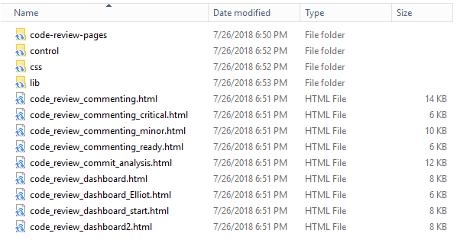

Code-review-pages:

* The example pages where different developers see different code review content.

Control:

* The control flow logic to navigate through the pages.

Css\:

* The style files for displaying the pages.

Lib\:

* The related java libraries for the prototype.

Code_review_commenting.html

* The page where developers can comment their code review result.

Code_review_commenting_critical.html

* The example page where developers can comment their evaluation for critical issues.

Code_review_commenting_minor.html

* The example page where developers can comment their evaluation for mintor issues.

Code_review_commenting_ready.html

* The example page where developers can comment their evaluation for ready status.

Code_review_commit_analysis.html

* The page where developers can see the analysis results for their commit.

Code_review_dashboard.html

* example page which will be directed into from code_view_dashboard_start.html.

code_review_dashboard_Elliot.html

* The page where Elliot can see the code commit review requests from their peer developers.

Code_review_dashboard_start.html

* The page where the developers can see the code commit review requests from their peer developers.

Code_review_dashboard2.html

* example page which will be directed into from code_view_dashboard_start.html.